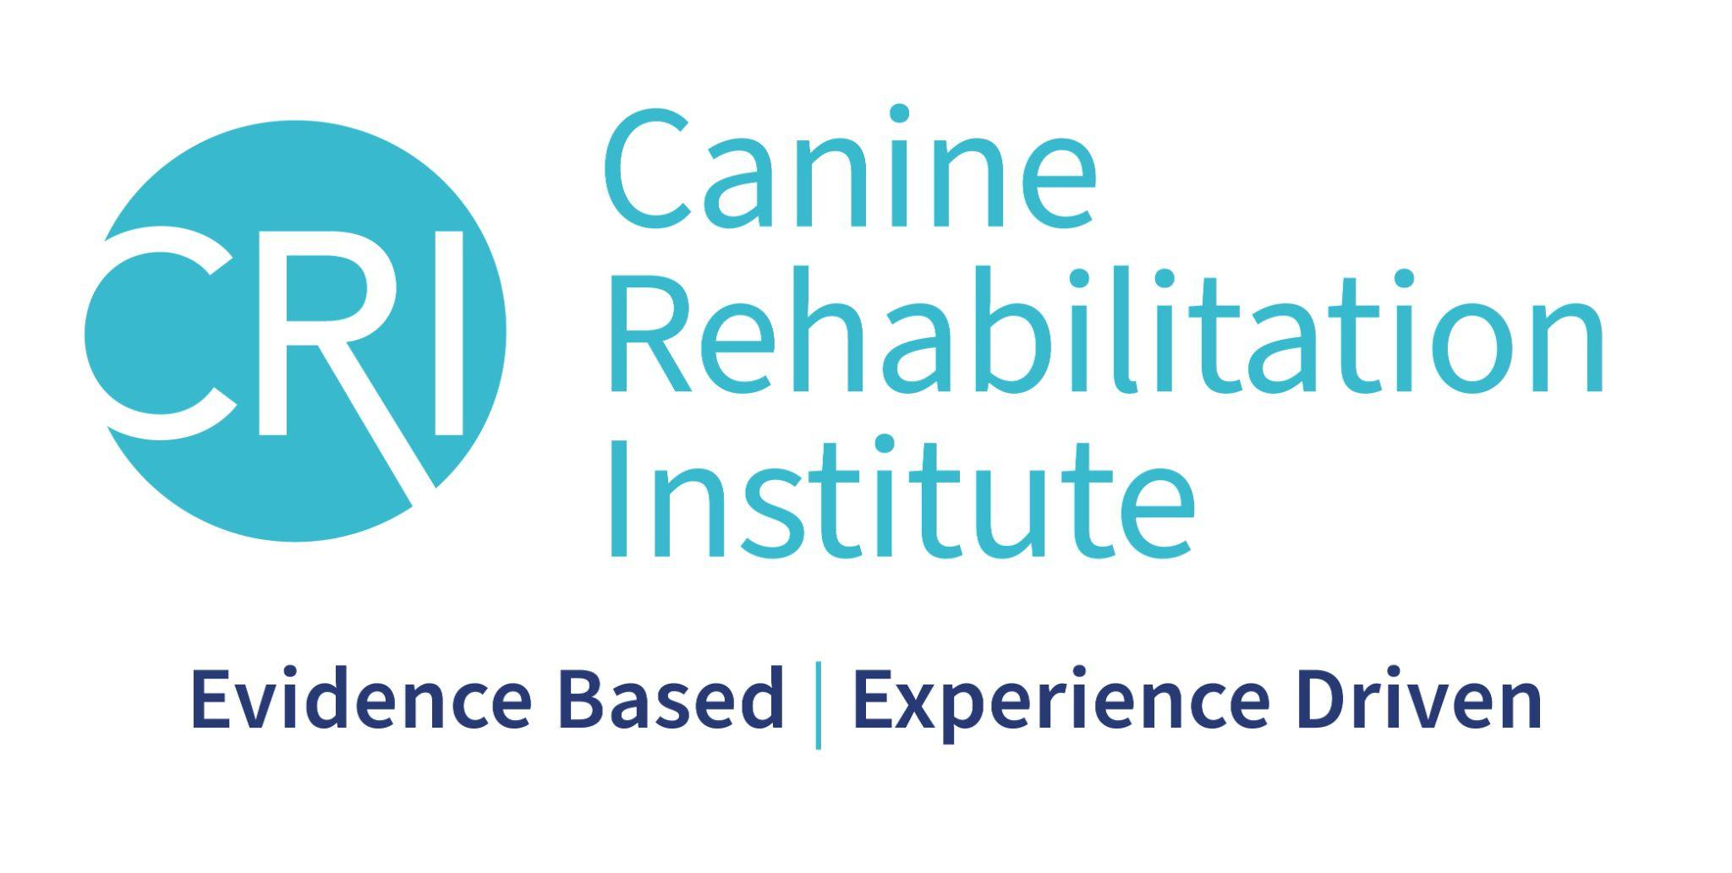

Letter of Recommendation

A letter of recommendation (LOR) is required for non-credentialed veterinary assistants registering for the Certified Canine Rehabilitation Assistant (CCRA) Program. We require at least one year of clinical experience for veterinary assistants.

This letter must be on practice letterhead and written by the applicant’s supervising veterinarian or physical therapist.

The LOR must be submitted when registering for each module, and the CCRA candidate must still be under the supervision of the veterinarian or physical therapist when completing the Internship step.

The following information should be included in the letter:

- Name, credentials, and contact information for the person providing the letter of recommendation

- Name of applicant

- How long the applicant has worked as a veterinary assistant

- How long has the applicant worked at the practice?

- Applicant’s understanding of the following:
  - Canine anatomy and biomechanics
  - Common orthopedic conditions, procedures, and acronyms
  - Common neurological presentations and surgeries

- Applicant’s experience handling client education

- Applicant’s ability to handle the rigors of the CCRA program and to commit to putting in the time to study and practice new techniques

Any other comments about the applicant’s suitability for the CCRA program

Please email a scanned copy of the letter of recommendation to info@caninerehabinstitute.com

PLEASE NOTE:
If a change in employment status occurs during the certification process and the applicant is no longer under the supervision of a rehabilitation certified veterinarian or physical therapist, they are not eligible to continue in the program until a new LOR is provided. It is the responsibility of the supervising veterinarian or physical therapist to notify us of this change.

